The Interplay of Site in Felice Varini’s Works Billie Lee, MFA 2009, Yale

For Varini’s site-specific works, namely, the “site” on which the artwork is installed plays a key role. The site of the work is not only where the work is located. For Felice Varini, it is the canvas and the environment in one; it determines how the work is viewed, experienced and interacts with the public. Therefore, when determining a site, Felice Varini looks for one that will maximize the experience of the work from many different perspectives.

“For me it would be very limiting to paint on a canvas which is closed within a frame of four sides. There is no relation to reality there. When I experience reality outside I do not know where it starts and where it ends. It is open, and the work is open. The space has no limits.”

The sites that Felice Varini has chosen for New Haven are two unique spaces in the heart of downtown that many pedestrians might have passed before without noticing their architectural qualities.
Varini’s site-specific paintings offer us a new perspective in experiencing familiar spaces. One is in an outdoor plaza and the other is in the historic New Haven Free Public Library—within walking distance from each other. We are able to experience how Felice Varini’s work functions in both exterior and interior environments. New Haven pedestrians can encounter these compelling works of public art on an afternoon stroll. Both Square with Four Circles and Three Black Circles in Air are installed in spaces that offer many ways of approaching the work. The urban space and the architectural elements become the canvas for Varini’s wall paintings and collages, and therefore, the way the viewer navigates the spaces and interacts with the architecture is as much part of the work as is the image that is created.

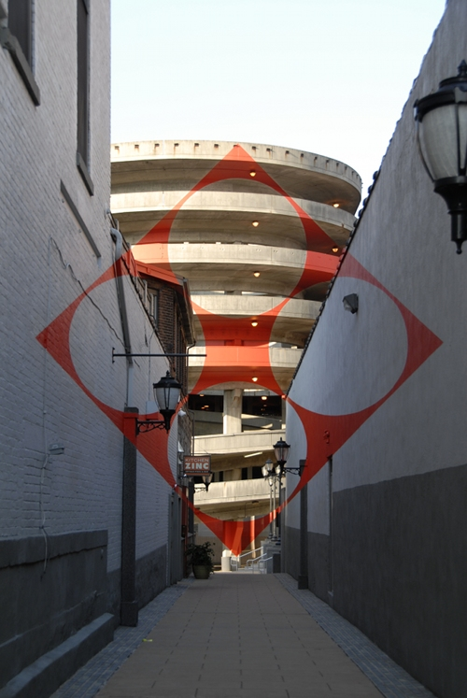 | 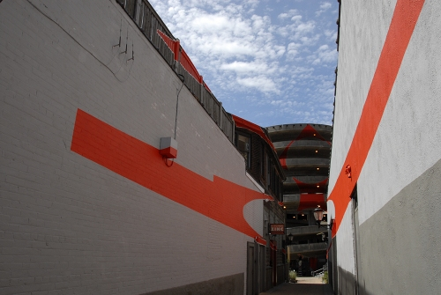

Square with Four Circles includes the pedestrian passageway from Chapel Street into Temple Plaza and the exterior surfaces of the sculptural concrete exit ramp of the Crown Street garage. Square with Four Circles is an excellent example of how Varini transforms a space into an experience. When he was interviewed, Varini spoke of the site as grabbing his attention because of its unique long narrow alleyway that opens up into a plaza-like space with an impressive architectural structure glaring down at you. He described Temple Plaza as having a European quality—similar to the narrow European streets that converge into a large open square. The site can also be entered from various entry points—there is no one way to “walk into” the piece.

Allen Appel, from the New Haven Independent writes, “The small street appealed to him. It was intimate, less traveled, and then, boom, there is the parking garage dominating the end of it like a lord of the manor. “I really like contrasts,” he said. “It’s for that I chose this.””

The second piece, Three Black Circles in Air, installed in the New Haven Free Public Library is the counterpart of the Square with Four Circles. The library with its classical dome-style architecture and wall frescos is also a European-like space, similar to what Varini saw in Temple Plaza. Three intersecting circles float on the second- and third-story balcony spaces of the library. The viewer’s eyes are drawn up to the high ceilings when entering the library. But the eyes do not stop there.

“The three-dimensionality of the architecture is suddenly alive again. The columns, balconies, walls and railings are now moving at different speeds…we are reminded of how space works.”

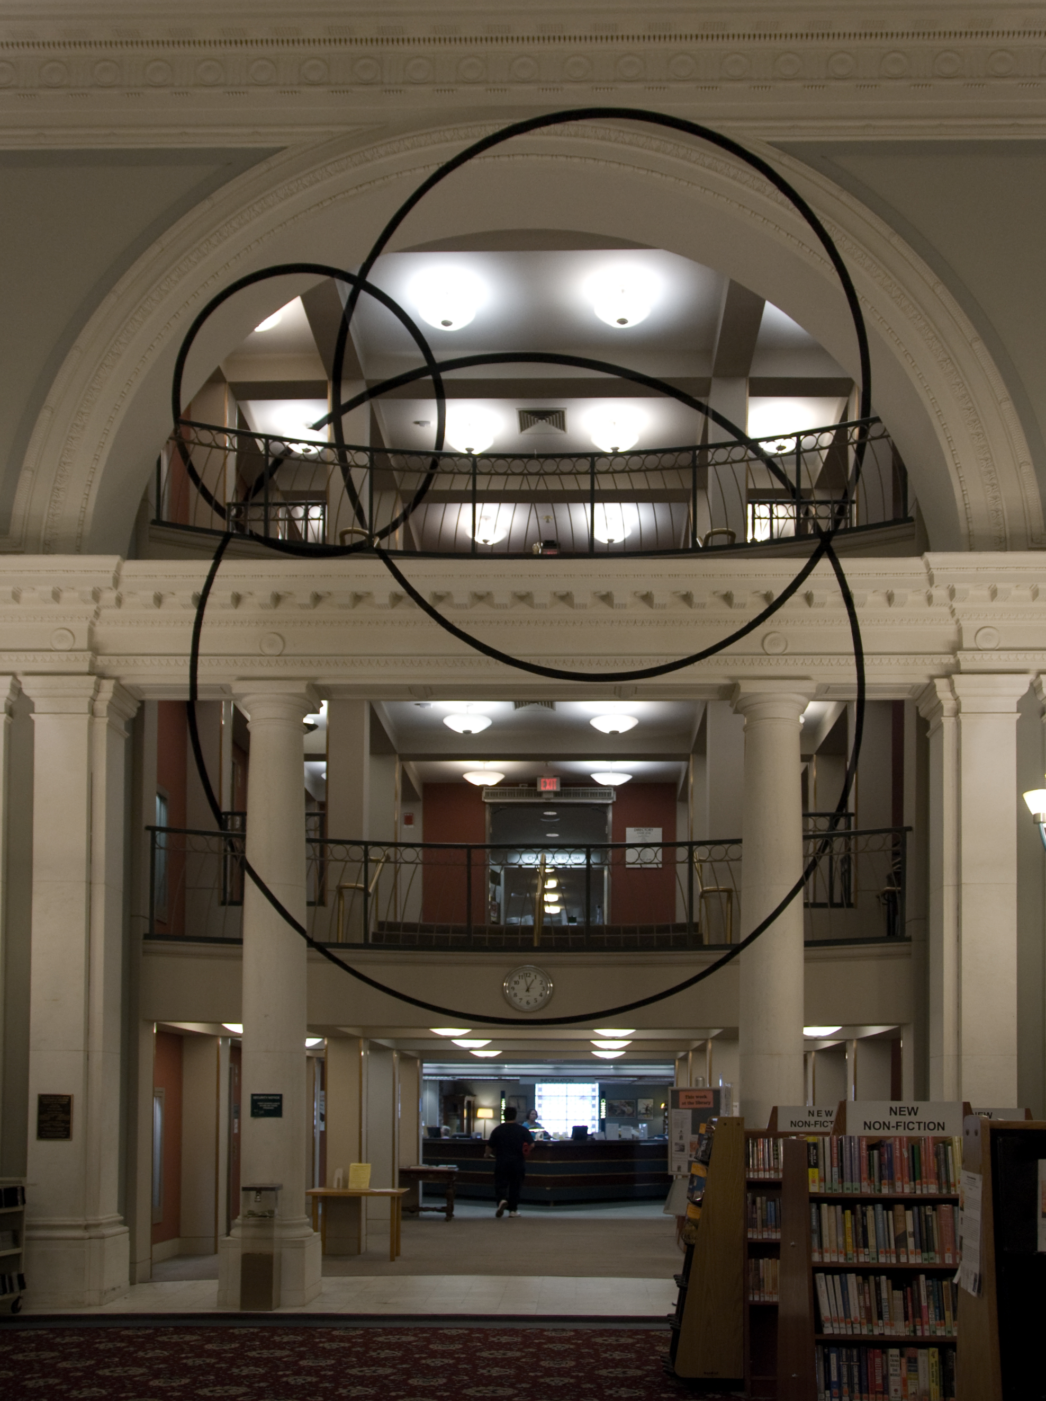 | 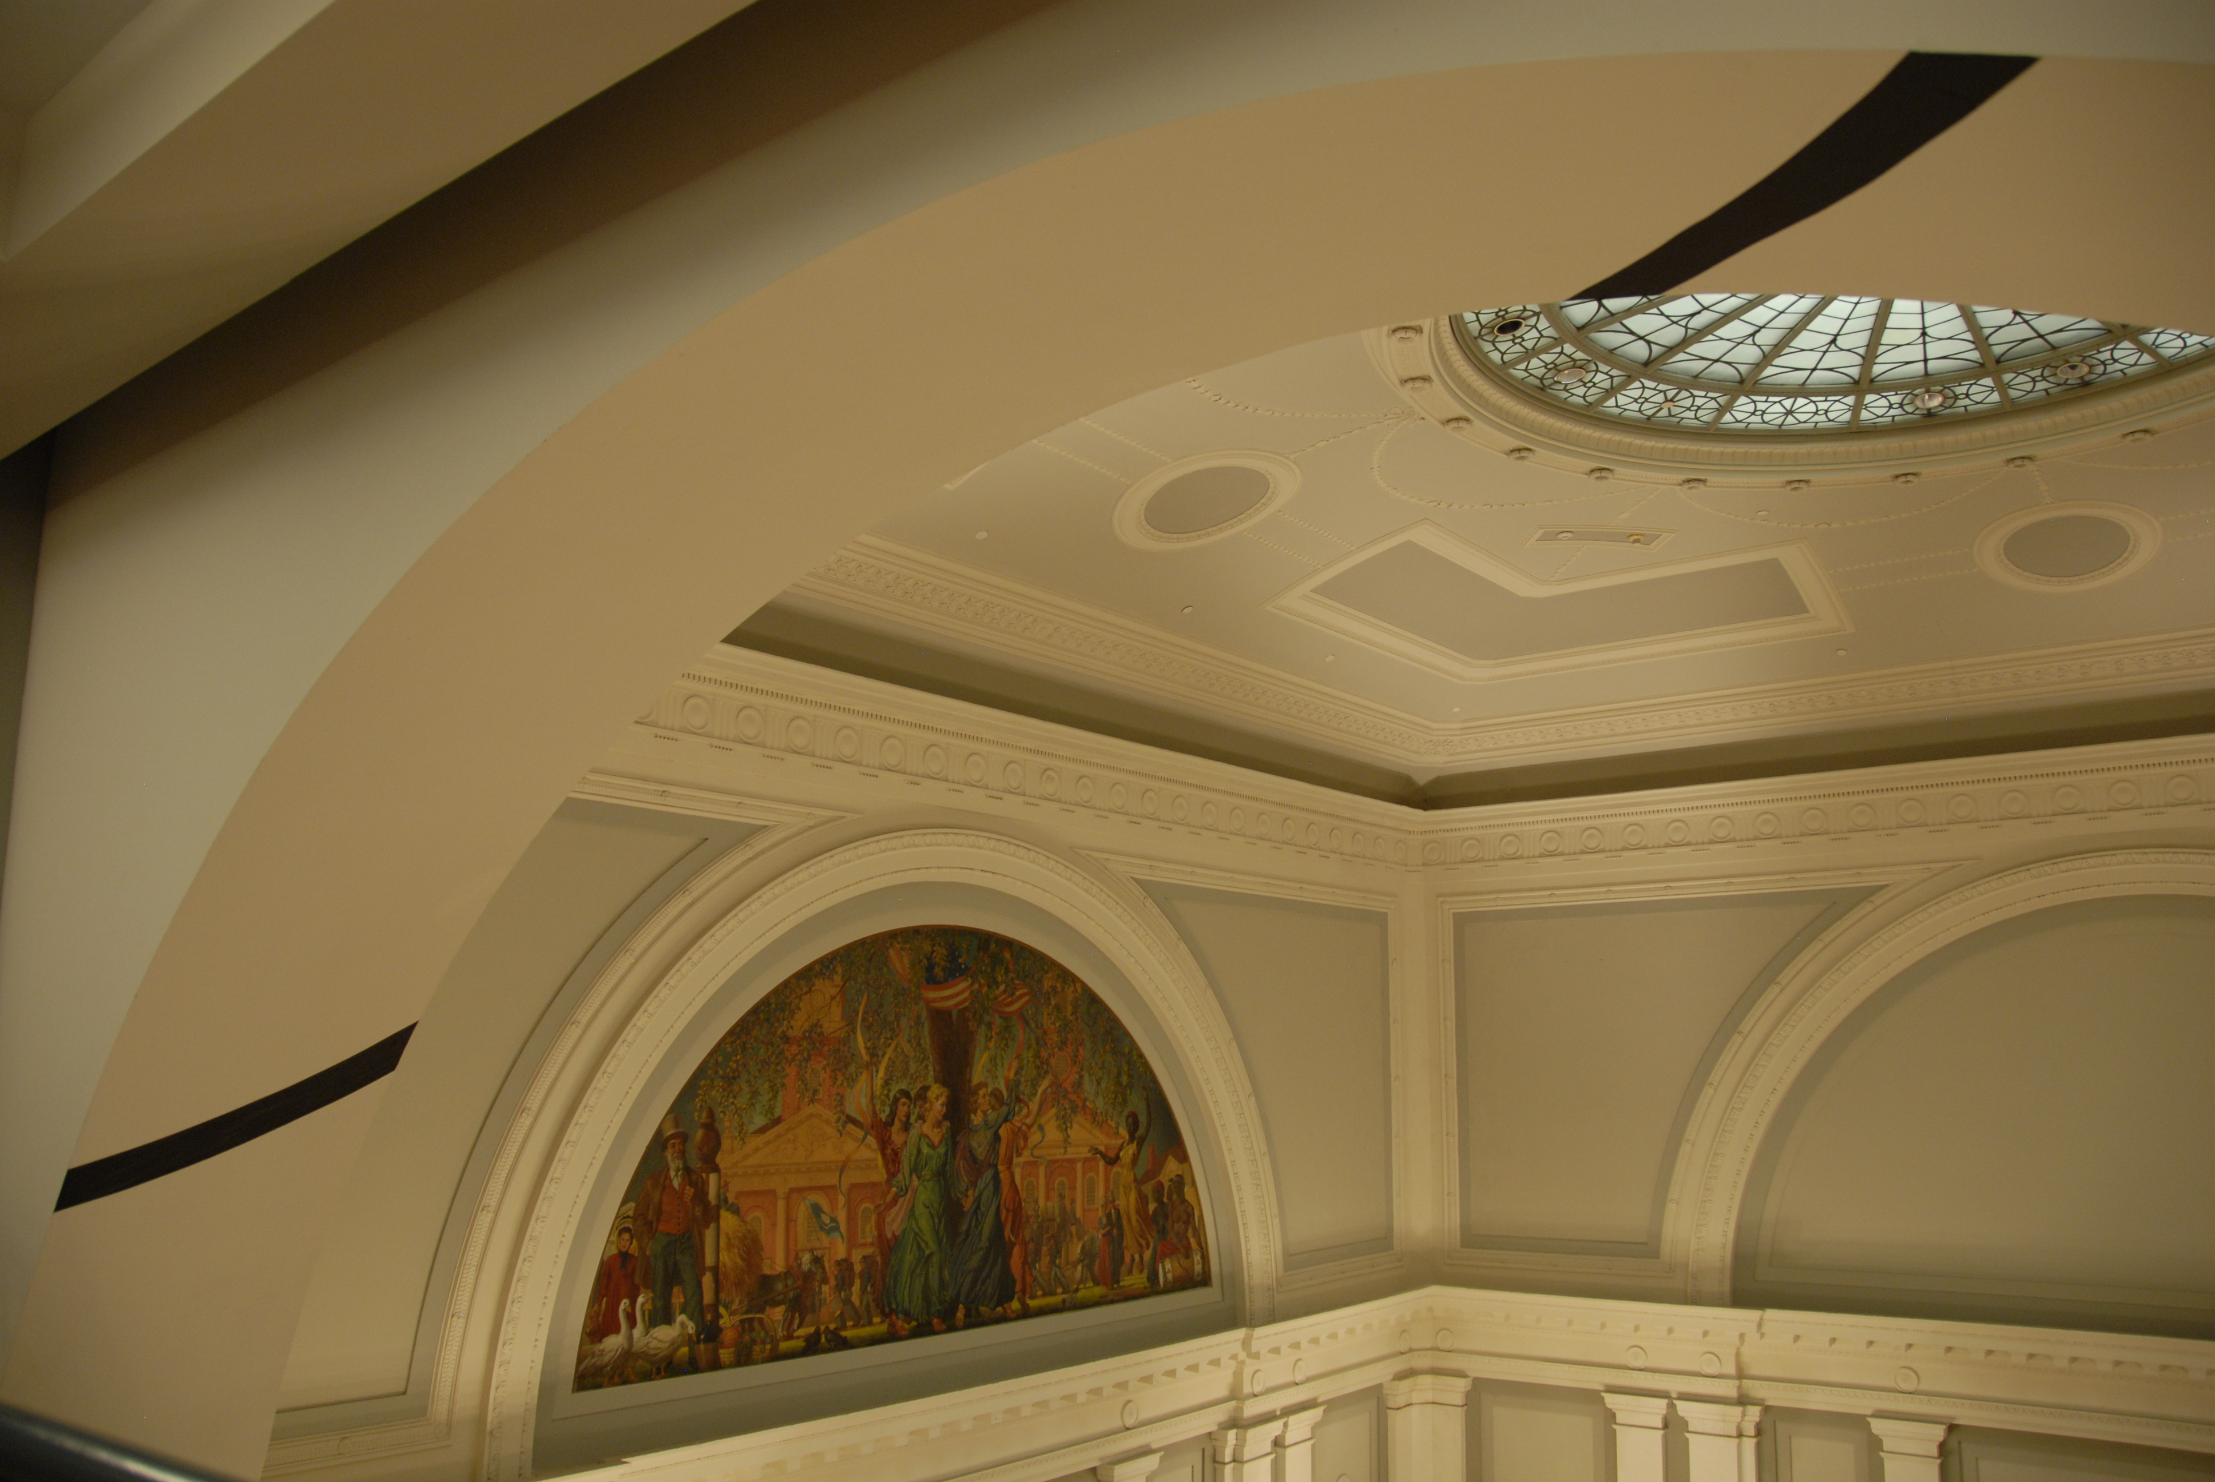

In a lecture given at the New Haven Public Library, architect Eric Epstein comments that when the viewer walks around the space, the unified image breaks apart and the image is immediately scattered throughout the space—allowing the eye to see the various details of the architecture.
“First, Varini selects deeply 3-dimensional spaces for his installations, spaces with a complexity of surface and variety of material. Even in the smaller interior work, like this piece in front of us, he chooses to install his pure geometry in a zone of convolution.”7

Upon close inspection, the viewer can notice that the painted fragments are on a variety of surfaces and planes of the library as well as in Temple Plaza. Some fragments are far behind, touching the very back wall, while others are sitting on the front railing and moldings. The paint is also on a variety of different materials: marble, plaster and metal. The interweaving areas of the site create a complex visual experience of the space that asks you to slow down and consider all of the elements that are a part of it. As Epstein says, “we are reminded of how space works.”

www.siteprojects.org

http://www.poeticmind.co.uk/interviews-1/i-am-a-painter/
Interview with students of Cooperative Arts High School After School Program. May, 2010.
http://www.newhavenindependent.org/index.php/archives/entry/public_art_wows_local_phlebotomist/
Art Spot Talk by Eric Epstein, New Haven Public Library. July 23, 2010.
7

